**Setting DIP Switches for 349-00080 (B-Series Software):**

Summary: Dip switch settings on board tell unit what model it is or will put the board into FCT mode. If dip switches are not set correctly, controls will assume the unit is a B-6, or if left in the default position, the board will be placed into FCT mode

**Details:**

There is a set of DIP switches on the component side of 348-00080 labeled “S1, MODEL”

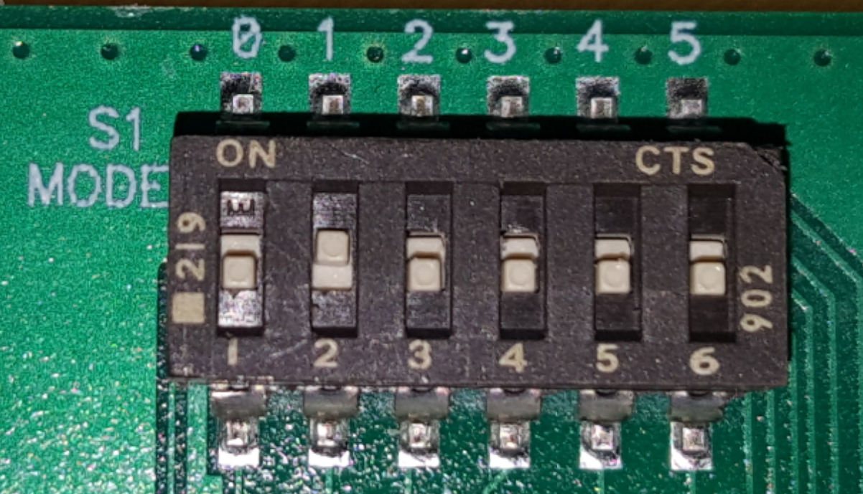

By default, all switches will arrive in the on position

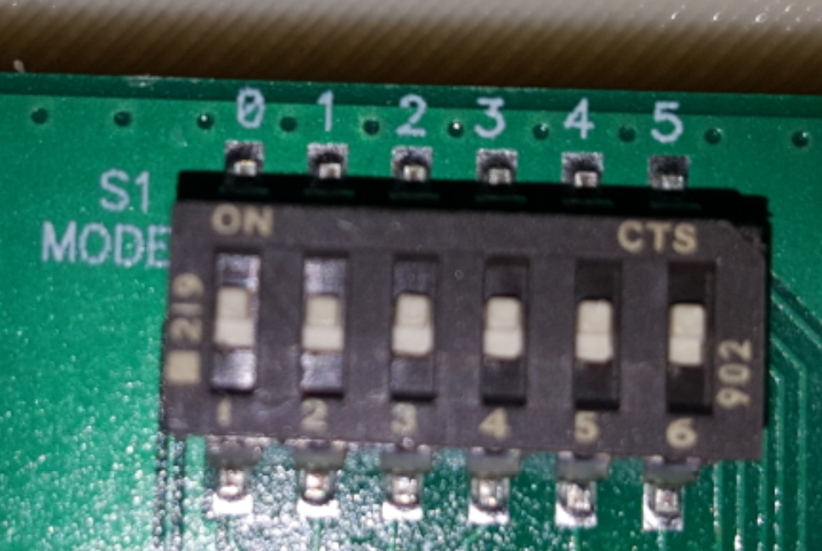

From the photos above, there are 6 switches for controlling what mode the machine will be

The following is a table of the following supported models (and will change in the future):

|  |  |  |  |  |  |  |  |
| --- | --- | --- | --- | --- | --- | --- | --- |
| MODEL | SWITCH 0 | SWITCH 1 | SWITCH 2 | SWITCH 3 | SWITCH 4 | SWITCH 5 | Value |
| BID | ON | OFF | OFF | OFF | OFF | OFF | 1 |
| B3 | OFF | ON | OFF | OFF | OFF | OFF | 2 |
| B-3WL | ON | ON | OFF | OFF | OFF | OFF | 3 |
| B-3WR | OFF | OFF | ON | OFF | OFF | OFF | 4 |
| B6 | ON | OFF | ON | OFF | OFF | OFF | 5 |
| B-SAP | OFF | ON | ON | OFF | OFF | OFF | 6 |
| B-SGP | ON | ON | ON | OFF | OFF | OFF | 7 |
| B-DAP | OFF | OFF | OFF | ON | OFF | OFF | 8 |
| B-DGP | ON | OFF | OFF | ON | OFF | OFF | 9 |
| DEFAULT  (FCT mode) | ON | ON | ON | ON | ON | ON | 64 |